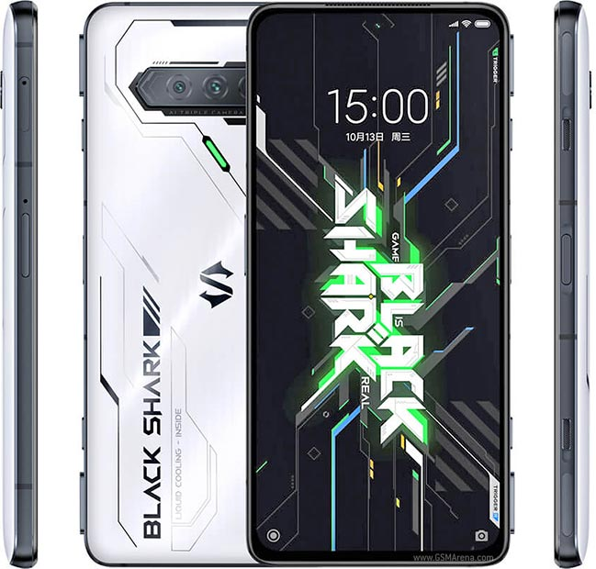**XIAOMI BLACK SHARK 4S PRO**

|  |  |  |
| --- | --- | --- |
| **NETWORK** | [**Technology**](https://www.gsmarena.com/network-bands.php3) | [GSM / CDMA / HSPA / EVDO / LTE / 5G](https://www.gsmarena.com/xiaomi_black_shark_4s_pro-11152.php) |
|  |  |

|  |  |  |
| --- | --- | --- |
| **LAUNCH** | [**Announced**](https://www.gsmarena.com/glossary.php3?term=phone-life-cycle) | 2021, October 13 |
| [**Status**](https://www.gsmarena.com/glossary.php3?term=phone-life-cycle) | Available. Released 2021, October 16 |

|  |  |  |
| --- | --- | --- |
| **BODY** | [**Dimensions**](https://www.gsmarena.com/xiaomi_black_shark_4s_pro-11152.php) | 163.7 x 76.2 x 9.9 mm (6.44 x 3.00 x 0.39 in) |
| [**Weight**](https://www.gsmarena.com/xiaomi_black_shark_4s_pro-11152.php) | 220 g (7.76 oz) |
| [**SIM**](https://www.gsmarena.com/glossary.php3?term=sim) | Dual SIM (Nano-SIM, dual stand-by) |
|  | Physical pop-up gaming triggers |

|  |  |  |
| --- | --- | --- |
| **DISPLAY** | [**Type**](https://www.gsmarena.com/glossary.php3?term=display-type) | Super AMOLED, 144Hz, HDR10+, 1300 nits (peak) |
| [**Size**](https://www.gsmarena.com/xiaomi_black_shark_4s_pro-11152.php) | 6.67 inches, 107.4 cm2 (~86.1% screen-to-body ratio) |
| [**Resolution**](https://www.gsmarena.com/glossary.php3?term=resolution) | 1080 x 2400 pixels, 20:9 ratio (~395 pip density) |
|  | Always-on display |

|  |  |  |
| --- | --- | --- |
| **PLATFORM** | [**OS**](https://www.gsmarena.com/glossary.php3?term=os) | Android 11, Joy UI 12.8 |
| [**Chipset**](https://www.gsmarena.com/glossary.php3?term=chipset) | Qualcomm SM8350 Snapdragon 888+ 5G (5 nm) |
| [**CPU**](https://www.gsmarena.com/glossary.php3?term=cpu) | Octa-core (1x3.0 GHz Kayo 680 & 3x2.42 GHz Kayo 680 & 4x1.80 GHz Kayo 680 |
| [**GPU**](https://www.gsmarena.com/glossary.php3?term=gpu) | Adreno 660 |

|  |  |  |
| --- | --- | --- |
| **MEMORY** | [**Card slot**](https://www.gsmarena.com/glossary.php3?term=memory-card-slot) | No |
| [**Internal**](https://www.gsmarena.com/glossary.php3?term=dynamic-memory) | 256GB 8GB RAM, 256GB 12GB RAM, 512GB 16GB RAM |
|  | UFS 3.1 |

|  |  |  |
| --- | --- | --- |
| **MAIN CAMERA** | [**Triple**](https://www.gsmarena.com/glossary.php3?term=camera) | 64 MP, f/1.8, (wide), 1/1.97", 0.7µm, PDAF 8 MP, f/2.2, 120˚ (ultrawide), 1/4.0", 1.12µm 5 MP, f/2.4, (macro), AF |
| [**Features**](https://www.gsmarena.com/glossary.php3?term=camera) | LED flash, HDR, panorama |
| [**Video**](https://www.gsmarena.com/glossary.php3?term=camera) | 4K@30/60fps, 1080p@30/60/240fps, 1080p@960fps; HDR10+ |

|  |  |  |
| --- | --- | --- |
| **SELFIE CAMERA** | [**Single**](https://www.gsmarena.com/glossary.php3?term=secondary-camera) | 20 MP, f/2.5, (wide), 0.8µm |
| [**Features**](https://www.gsmarena.com/glossary.php3?term=secondary-camera) | HDR |
| [**Video**](https://www.gsmarena.com/glossary.php3?term=secondary-camera) | 1080p@30fps |

|  |  |  |
| --- | --- | --- |
| **SOUND** | [**Loudspeaker**](https://www.gsmarena.com/glossary.php3?term=loudspeaker) | Yes, with stereo speakers |
| [**3.5mm jack**](https://www.gsmarena.com/glossary.php3?term=audio-jack) | Yes |
|  | 24-bit/192kHz audio |

|  |  |  |
| --- | --- | --- |
| **COMMS** | [**WLAN**](https://www.gsmarena.com/glossary.php3?term=wi-fi) | Wi-Fi 802.11 a/b/g/n/ac/6, dual-band, Wi-Fi Direct, hotspot |
| [**Bluetooth**](https://www.gsmarena.com/glossary.php3?term=bluetooth) | 5.2, A2DP, LE, apt HD, apt Adaptive |
| [**GPS**](https://www.gsmarena.com/glossary.php3?term=gps) | Yes, with A-GPS, GLONASS, GALILEO, QZSS, BDS |
| [**NFC**](https://www.gsmarena.com/glossary.php3?term=nfc) | Yes |
| [**Radio**](https://www.gsmarena.com/glossary.php3?term=fm-radio) | No |
| [**USB**](https://www.gsmarena.com/glossary.php3?term=usb) | USB Type-C 2.0 |

|  |  |  |
| --- | --- | --- |
| **FEATURES** | [**Sensors**](https://www.gsmarena.com/glossary.php3?term=sensors) | Fingerprint (side-mounted), accelerometer, gyro, proximity, compass, barometer |
|  |  |

|  |  |  |
| --- | --- | --- |
| **BATTERY** | [**Type**](https://www.gsmarena.com/glossary.php3?term=rechargeable-battery-types) | Li-Po 4500 math, non-removable |
| [**Charging**](https://www.gsmarena.com/glossary.php3?term=battery-charging) | Fast charging 120W, 50% in 5 min, 100% in 15 min (advertised) |

|  |  |  |
| --- | --- | --- |
| **MISC** | [**Colors**](https://www.gsmarena.com/glossary.php3?term=build) | Black, White |
| [**Price**](https://www.gsmarena.com/glossary.php3?term=price) | About 650 EUR |

**Disclaimer.** We cannot guarantee that the information on this page is 100% correct. [Read more](https://www.gsmarena.com/glossary.php3?term=data-disclaimer)